**Internet gateway**

To allow public traffic from the internet to access your VPC, you attach an **internet gateway** to the VPC.

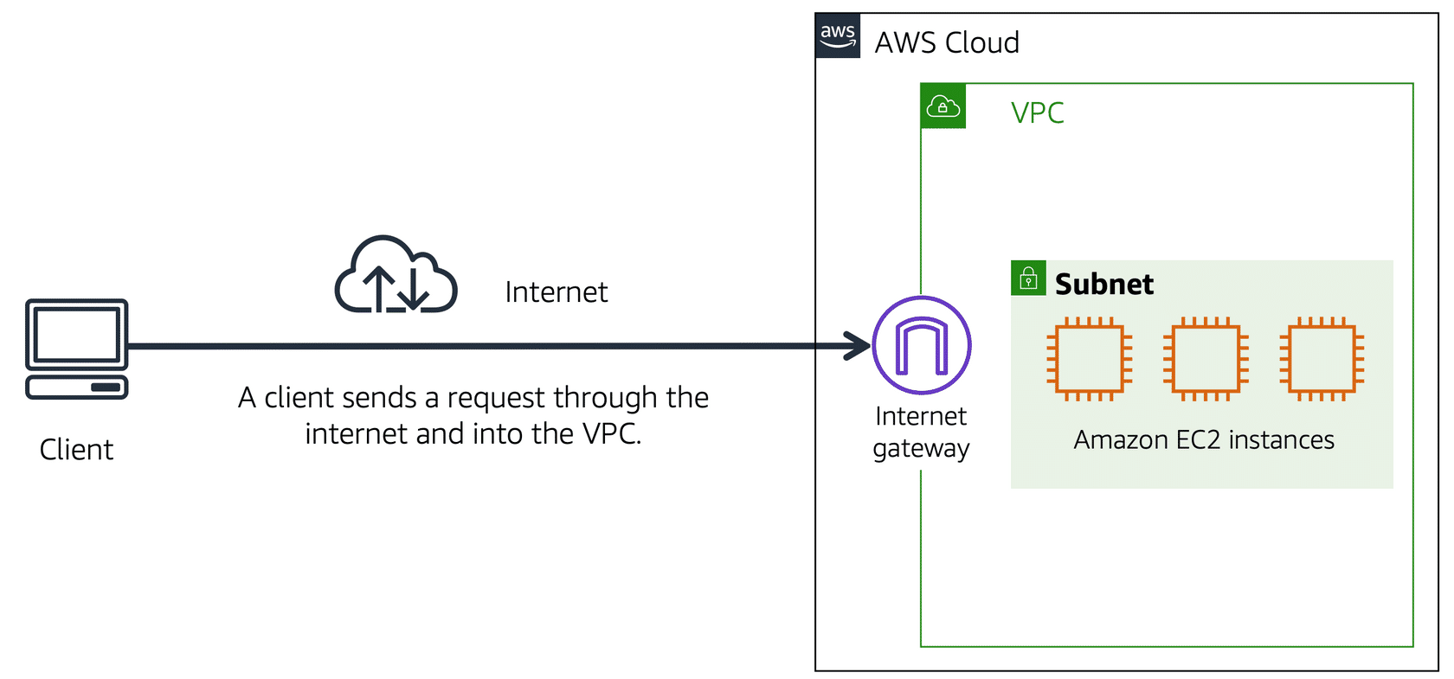

An internet gateway is a connection between a VPC and the internet.

**Virtual private gateway**

To access private resources in a VPC, you can use a **virtual private gateway**.

Here’s an example of how a virtual private gateway works. You can think of the internet as the road between your home and the coffee shop. Suppose that you are traveling on this road with a bodyguard to protect you. You are still using the same road as other customers, but with an extra layer of protection.

The bodyguard is like a virtual private network (VPN) connection that encrypts (or protects) your internet traffic from all the other requests around it.

The virtual private gateway is the component that allows protected internet traffic to enter into the VPC. Even though your connection to the coffee shop has extra protection, traffic jams are possible because you’re using the same road as other customers.

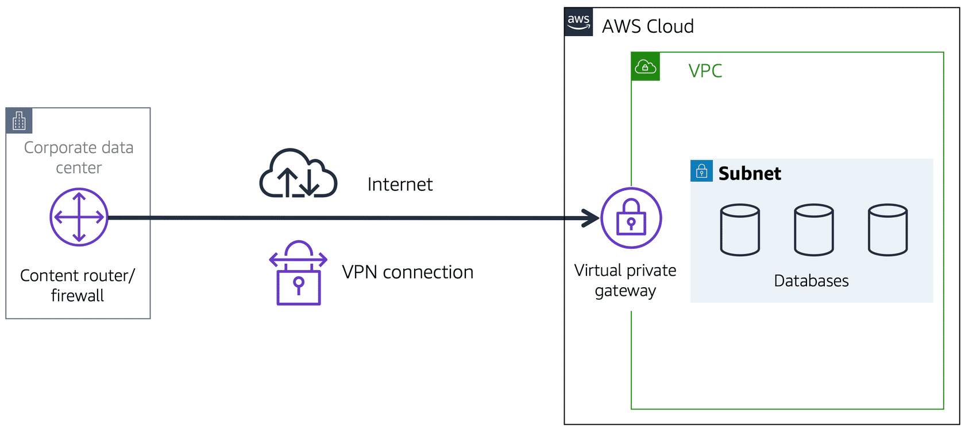

A virtual private gateway enables you to establish a virtual private network (VPN) connection between your VPC and a private network, such as an on-premises data center or internal corporate network. A virtual private gateway allows traffic into the VPC only if it is coming from an approved network.

**AWS Direct Connect**

[**AWS Direct Connect**](https://aws.amazon.com/directconnect/) is a service that enables you to establish a dedicated private connection between your data center and a VPC.

Suppose that there is an apartment building with a hallway directly linking the building to the coffee shop. Only the residents of the apartment building can travel through this hallway.

This private hallway provides the same type of dedicated connection as AWS Direct Connect. Residents are able to get into the coffee shop without needing to use the public road shared with other customers.

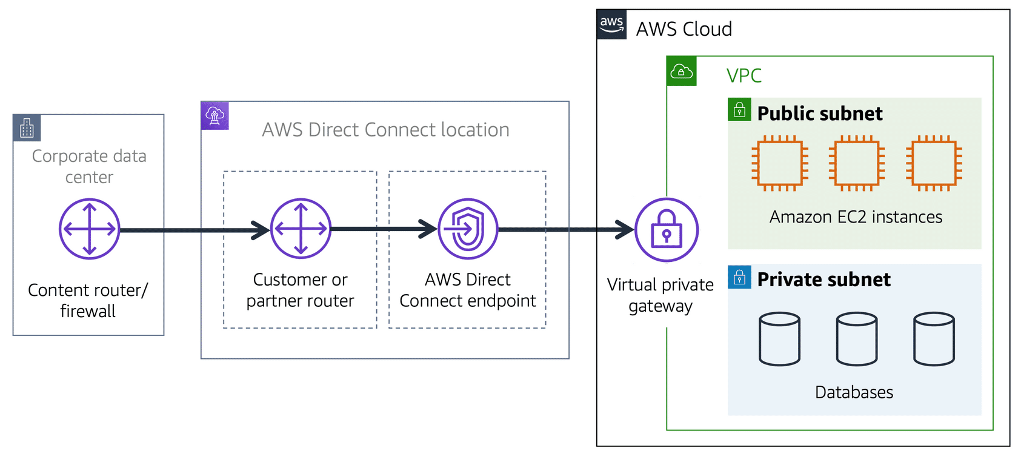

The private connection that AWS Direct Connect provides helps you to reduce network costs and increase the amount of bandwidth that can travel through your network.